On the rise, the rate of growth

Growth of members, likes, favorite, the amount of times its name comes up in the public groupchat (similar to keyword trending on twitter), visits of the community, which categories are most active, shares, community’s group chat activity

There probably should be a time window of reavalutaion

Likes and favorites and other things should come from unique users

What happens when there is no activity

ranking = (numberOfComments * commentsWeight + numberOfLikes * likesWeight) / (daysSincePost * gravity)  
gravity was 0.2  
commentsWeight 2  
likesWeight 1

**return** (votes - 1) / pow((item_hour_age+2), gravity)

Reddit

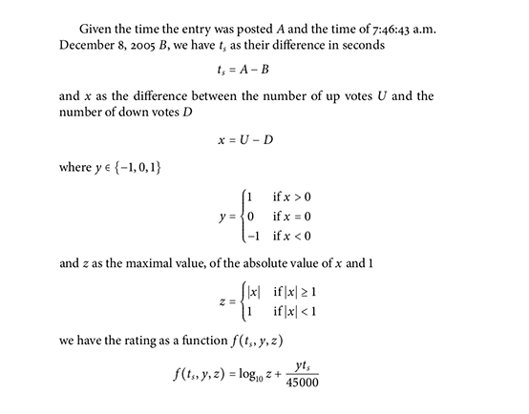

<https://medium.com/hacking-and-gonzo/how-reddit-ranking-algorithms-work-ef111e33d0d9>

<https://medium.com/hacking-and-gonzo/how-hacker-news-ranking-algorithm-works-1d9b0cf2c08d>

<https://www.indiehackers.com/post/how-to-make-a-trending-algorithm-684031c9eb>

<https://www.michael-noll.com/blog/2013/01/18/implementing-real-time-trending-topics-in-storm/>

the formula

f() = (numberOfNewLikes * likesWeight + numberOfNewFavorites * favoriteWeight + netNewMembers * membersWeight + numberOfShares * sharesWeight)

for example reevaluate after 2days and at the end of each day half the score // or + or – depending when the likes and favorites were given (the reddit model)

then we can add the number of times it appears from different users on the public group chat and activity of the community chat from unique members